|  |  |  |
| --- | --- | --- |
| BINGHAMTON HIGH SCHOOL  BINGHAMTON - SCHOOL |  |  |
|  |  |  |
| School Detail :- Binghamton High School, a combined high school of the previous Binghamton North High School and Binghamton Central High School, is a large public high school located in the center of Binghamton, New York. The school is culturally diverse, with 1600+ students from many different countries, religions, and income levels.  BHS is home to the internationally recognized Rod Serling School of Fine Arts and features more than 22 performing groups. The school puts on a fall play, a spring musical and various concerts throughout the year. The school also features one of only a handful of steel drum bands in the state. |  |  |
|  |

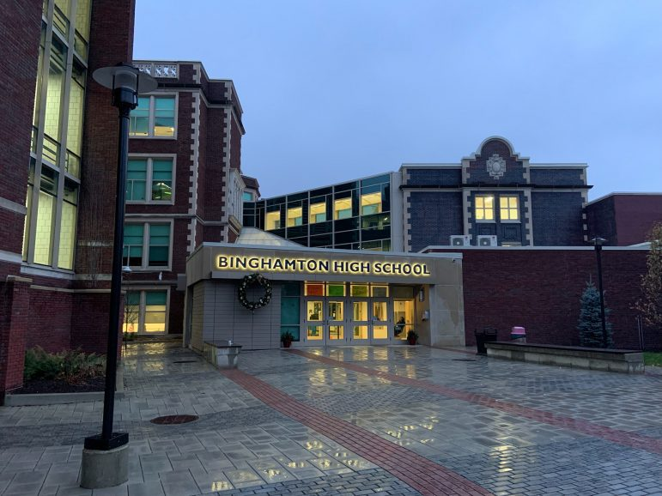

MINIMUM CAPACITY :-

The Minumum intake capacity

of students is between 1100-1320

children

LIBRARY :-

The Libarary is Available.

CANTEEN:-

The Canteen Facility is Available.

BOARDING :-

No availablility of boarding.

SPORTS :-

There are different categories

sports available.

Girls Volleyball

Boys Volleyball

Football